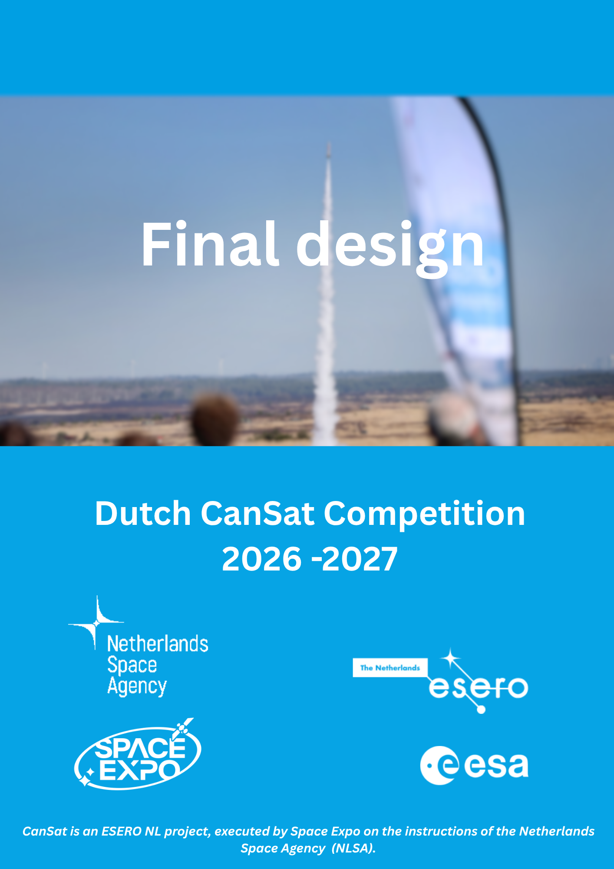

Dutch CanSat Competition Final Design

The Final Design is your final report before Launch. This report summarises all the work performed to date. This document should accurately record all the details of the completed CanSat prototype and provide a full description of the CanSat system and its functionalities
Based on the Final Design, the work and performance of each team will be reviewed by a team of experts. Based on these reviews, the organisers will select the best ten teams who will have the opportunity to launch their CanSat with the CanSat rocket at the CanSat launch event.
The maximum length of the Final Design is 9500 words.

The completed Final Design, including a retrieval form must be e-mailed before 23 February. 13.00 hrs. to info@esero.nl. Please use the subject line: “CanSat Final Design [TEAM NAME]”.
Instructions
This is a template for your CanSat Final Design. Please copy and paste the template into a separate document and follow it as it is, but leave out the instructions. Maximum page limit 9500 words. Please do not forget to include the Retrieval Form at the end of this document.

In the Final Design it is important that you
- Give detailed descriptions of your CanSat secondary mission and design. Describe and explain any adjustments you made on the plan you described in your proposal
- Show that your design is technical correct and achievable within time, budget and technical requirements.
- Proof that you meet all the technical requirements. If you do not meet the criteria, your CanSat cannot be launched at the Launch Event! Show measurements. Show calculations (in text, no scans allowed). Describe test results that demonstrate that your CanSat design does meet the criteria or add photos or drawings.
- Be specific, a simple yes or no is not enough
! If you want to add photos or drawings as a proof, you can add them in section vi.

Template Final Design

General

Team:

School:

City:

- Mission Overview
  - Primary Mission
(List the objectives of the primary mission)

  - Secondary Mission
(Describe your secondary mission. Explain why you have chosen this mission. Why is it important)

  - Scientific and/or technical objectives
(Outline the scientific and/or technical objectives of your secondary mission. Highlight any innovative aspects. Explain how you are going to fulfill the objectives of your secondary mission)

  - Data measurements and analyses
(Which data will you measure and how? How will you process or analyze the obtained data?)

  - Design
(Demonstrate the design of the CanSat construction, the ground station and yagi-antenna. Demonstrate the design of your parachute)

  - Testing
((Describe your tests and the results they gave. Did you encounter any problems with your primary or secondary mission, the CanSats construction, parachute design or ground station at the Test Day or at any other tests you did? If so, what actions have you taken to solve these problems?)

  - Adjustments original design plan
(Describe and justify any adjustments you made on the original design plan as stated in the proposal)
- CanSat Technical Requirements
The CanSat hardware and missions must be designed to the following requirements and constraints. Demonstrate how your design meets these criteria.

Requirement 1 Dimensions
(All the components of the CanSat must fit inside a standard soda can (115 mm height and 66 mm diameter), apart from the parachute. An exemption can be made for radio antennas and GPS antennas, which can be mounted externally (on the top or bottom of the can, not on the sides), based on the design. N.B. The rocket payload area has 4.5 cm of space available per CanSat, along the can’s axial dimension (i.e. height), which must accommodate all external elements including parachute, parachute attachment hardware, and any antennas)

Requirement 2 Extensions
(The antennas, transducers and other elements of the CanSat cannot extend beyond the can’s diameter until it has left the launch vehicle)

Requirement 3 Weight
(The mass of the CanSat must be between 300 grams and 350 grams. CanSats that are lighter must take additional ballast with them to reach the 300 grams minimum mass limit required)

Requirement 4 Dangerous materials
(Explosives, detonators, pyrotechnics, and flammable or dangerous materials are strictly forbidden. All materials used must be safe for the personnel, the equipment and the environment. Material Safety Data Sheets (MSDS) will be requested in case of doubt)

Requirement 5 Parachute strength
(The parachute connection must be able to withstand up to 50 N of force. The strength of the parachute must be tested, to give confidence that the system will operate nominally)

Requirement 6 Vibrations
(The CanSat must be able to withstand vibrations resulting from an acceleration of up to 20 G. This vibrational load is applied to the CanSat during the propelled portion of the launch.
Explain what tests you have performed to prove this. (Be sure to perform this test with electronics aboard, as these form the most vulnerable part)

Requirement 7 Flight time
(A maximum flight time of 90 seconds is mandatory. This maximum flight time also applies if attempting a directed landing. It takes approximately 13 seconds for the rocket to get to 1 km height and release the CanSat. So the CanSats should descend from 1 km to the ground in 77 seconds. This implies an average descent rate of 13 m/s.
When systems other than single stage parachuting are used, exceptions are possible in consultation well before handing in the Final Design. Proof that you have extensively tested your system and that it is safe)

Requirement 8 Parachute security
(In the case you use a larger parachute that is actively deployed at a later point in your CanSat flight, it must be ensured that the parachute stays secured until your moment of deployment. Both in terms of the mechanical system and the electrical/software actuation. If you use such a parachute, describe/show your release mechanism here)

Requirement 9 Power supply
(The CanSat must be powered by a battery and/or solar panels. The systems must be able to be activated for four hours non-stop without the battery running low. The battery must be easily accessible if it has to be replaced/recharged)

Requirement 10 Power switch
(The CanSat must have an easily accessible master power switch)

Requirement 11 Recovery system
(The CanSat should have a recovery system, such as a parachute, capable of being reused after launch. It is recommended to use bright colored fabric, which will facilitate recovery of the CanSat after landing)

Requirement 12 Retrieval system
(Inclusion of a retrieval system (beeper, radio beacon, GPS, etc.) is recommended)
- Outreach
  - Outreach Plan
(Describe your outreach program and activities)

  - Progress
(Describe the work you have already done for your outreach program and what you are planning to do, if you are selected for launch)
- Project management

  - Process Summary
(How did you address the assignment? Give a brief statement on the process and the steps you have taken. Did you encounter any problems during the project? How did you cope with these situations? You do not need to get into detail about technical problems. Details on technical issues can be mentioned in earlier sections)

  - Team
(How did you distribute the work between the team members? How did this work out? Consider all aspects of your project (structure, software, data analysis, communication, outreach, etc.).
  - Cansat Status
(What is the status of your CanSat? Which tasks still need to be done?)

  - Planning
(How much time did you spend on your CanSat project? Show a log of your project planning)

  - Finance
(Provide a budget overview of your CanSat project, including a list of all your expenses and the total amount you have spent. Show how you financed your expenses. In case of sponsorship: make a list of sponsors and the amount per sponsor
Take into account that the total budget of the final CanSat model should not exceed 600€. This includes 100€ for the Cansat Starter Kit). Ground Stations and any related non-flying item (e.g. outreach) will not be considered in the budget)

- Evaluation
(Describe your progress and motivation. What motivated you to participate in the competition? What did you learn from this experience so far? Did the project did meet your expectations)

Retrieval document CanSat

After launch, personnel at the launch site will retrieve your CanSat. The information below and a good picture helps them to find you CanSat

Team name | Klik of tik om tekst in te voeren.
Short description of secondary mission | Klik of tik om tekst in te voeren.
Description of visual characteristics CanSat (colour scheme) | Klik of tik om tekst in te voeren.
Description of visual characteristics parachute(s) (size, shape, colour scheme) | Klik of tik om tekst in te voeren.
List any systems aboard that aid the recovery of your CanSat (GPS, beeper) | Klik of tik om tekst in te voeren.
List any batteries you have on board (type + number) in case they need to be contained if the CanSat crashes (for instance: LiPo batteries, 2x) | Klik of tik om tekst in te voeren.

[Picture of your CanSat] [Picture of your parachute (with CanSat)]



