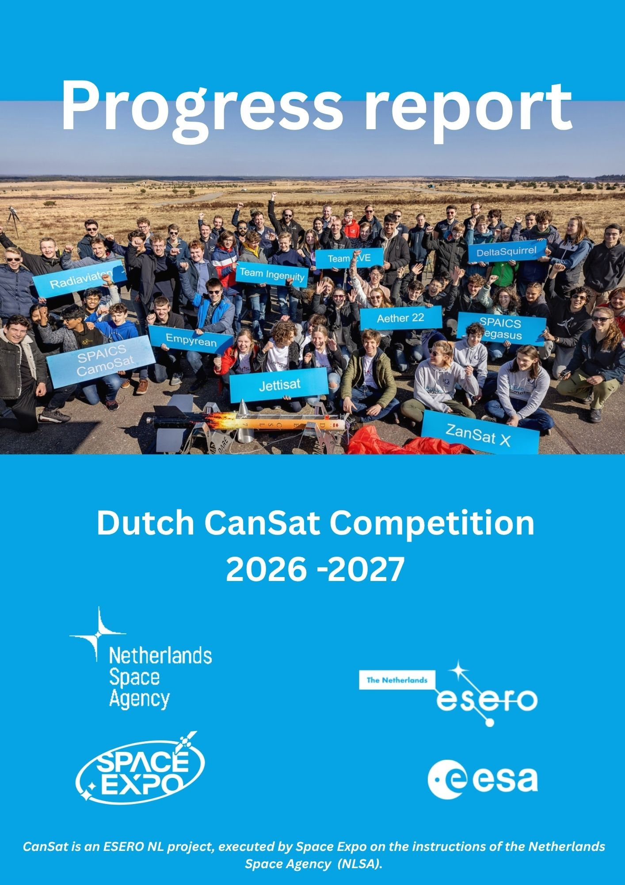

[Bedrijfsnaam]
[Titel van document]
[Ondertitel van document]

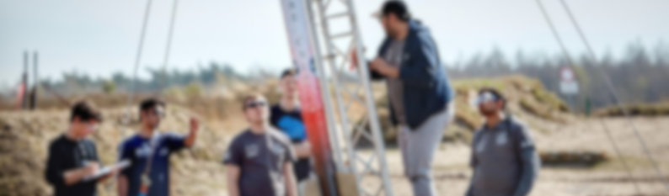
Progress report

The Progress Report gives the CanSat organisers an update on the development of your CanSat and the progress of your mission.
The report helps us understand how your project is evolving, what challenges you have encountered and how you are preparing for the launch campaign.
After submitting your report, you will receive feedback during the Test Day, where your team will discuss the project with a CanSat expert.

Submission
Email your completed Progress Report to:
info@esero.nl

Use the following subject line:
“CanSat Progress Report [TEAM NAME]”

Maximum length
6,500 words

Progress report

Progress Report Template
Please remove the instructional text in the template and leave only the headings and subheadings. You can then add your own content under each section.

General Information
Team Name:
School:
City:
Progress Statement
Provide a short summary of your progress so far. This section should give a quick overview of:
- important developments since the proposal phase;
- completed work;
- ordered or received components;
- challenges encountered;
- solutions implemented;
- remaining risks or open issues;
- major achievements or successes.

1. Mission Overview
1.1 Primary Mission
List the objectives of the primary mission.Explain briefly how your CanSat will fulfil these objectives.

Progress report

1.2 Secondary Mission
Describe your secondary mission. If any changes have been made since the proposal was submitted, explain:
- what has changed;
- why the change was necessary;
- how it affects the project.

1.3 Scientific and Technical Objectives
Describe your scientific and technical objectives. Explain how you plan to achieve them, for example through:
- specific sensors;
- hardware solutions;
- software development;
- data analysis methods;
- mechanical design choices.
If anything has changed since your original proposal, explain those changes.

1.4 Data Collection and Analysis
Describe concise but clear:
- which data you will collect;
- how the data will be measured;
- how often measurements will be taken;
- how you plan to analyse the collected data.

Progress report

2. CanSat Design and Technical Requirements
2.1 Design Specifications
Describe the current design of your CanSat. Provide sufficient detail to demonstrate that your design is technically feasible. Include:
- system overview;
- hardware components;
- software architecture;
- design sketches;
- diagrams;
- calculations where relevant.

2.2 Testing
Describe your testing plan. Include:
Tests already completed
- What was tested?
- What were the results?
- What did you learn?
Planned tests
- Which tests still need to be performed?
- Why are they important?
- When will they take place?

Progress report

2.3 Compliance with Technical Requirements
Explain how your CanSat meets each of the technical requirements listed below. If a requirement has not yet been met, explain how you plan to achieve compliance. Support your explanations with:
- calculations;
- diagrams;
- photographs;
- test results.

Requirement 1: Dimensions
All CanSat components must fit inside a standard soft drink can:
- Height: 115 mm
- Diameter: 66 mm
The parachute may be stored outside the can. External antennas may be allowed on the top or bottom of the CanSat, depending on the design.
Describe:
- your current dimensions;
- any external components;
- the dimensions of those components.

Requirement 2: Deployment Configuration
Before deployment from the rocket, antennas, sensors and other components may not extend beyond the CanSat diameter.

If your design includes moving parts, explain how these remain secured until deployment. Provide evidence where possible.
Requirement 3: Mass
The total mass of the CanSat must be between:
- 300 g minimum
- 350 g maximum
If your CanSat currently falls outside this range, explain how you plan to comply with the requirement.

Requirement 4: Parachute Strength
The parachute attachment system must withstand at least:
- 50 N required
- 200 N recommended
Describe:
- your parachute attachment design;
- any strength tests performed;
- the results of those tests.

Requirement 5: Launch Loads and Vibrations
Your CanSat must withstand launch conditions equivalent to accelerations of up to 20 G. Include results and evidence where available. Describe:
- tests already completed;
- planned tests;
Progress report
- how sensitive components such as electronics will be protected.

Requirement 6: Descent Rate
For safety and recovery purposes, the average descent rate must be at least:
13 m/s
Describe:
- your parachute design;
- parachute dimensions;
- calculations;
- testing plans;
- expected descent performance.
If you are using a more advanced recovery system, describe it in detail and explain why it meets the requirements.

3. Outreach
3.1 Outreach Plan
Describe your outreach activities. Explain:
- your target audience(s);
- why you selected those audiences;
- the message you want to communicate;
- how you plan to reach them.

Progress report

Examples include:
- social media;
- newspaper articles;
- interviews;
- school presentations;
- websites or blogs;
- community events.

3.2 Outreach Progress
Describe the outreach activities completed so far. Include:
- events organised;
- presentations delivered;
- media coverage received;
- social media activity;
- audience reach if available.

4. Project Management
4.1 Team
Describe how your team is organised. If responsibilities or team roles have changed since the proposal stage, explain:
- what changed;
- why the changes were made;
Progress report
- how they improved the project.
Progress report

4.2 Planning
Evaluate your project planning. Include an updated planning overview if available. Consider:
- Are you still on schedule?
- Have any milestones been delayed?
- Have new activities been added?
- What actions have you taken to stay on track?

4.3 Finance
Review your project budget. Describe:
- current expenses;
- expected remaining costs;
- any budget changes;
- sponsorship activities;
- financial contributions from your school or other partners.
If you are seeking sponsorship, explain the status of your efforts.

Thank you for your progress report. We look forward to following the development of your CanSat and wish your team success in the next phase of the project.

