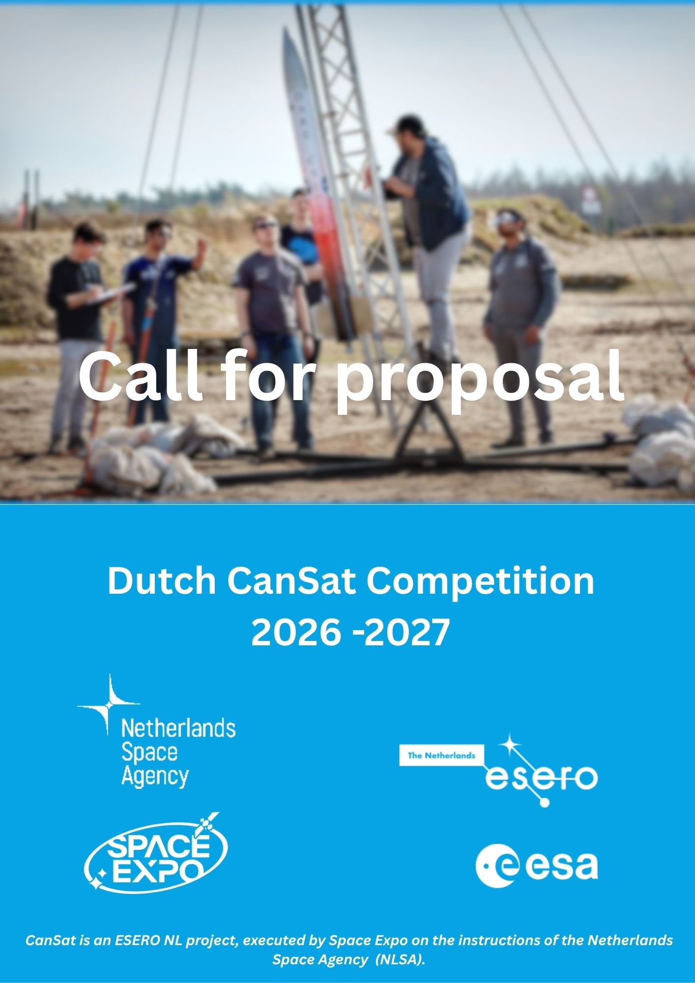

Have you ever dreamed of becoming an astronaut, rocket scientist, or space engineer?
Now is your chance!

During the CanSat Competition, you and your team will design, build and test your own satellite the size of a soft drink can. You will develop a mission, collect data and compete against teams from across the Netherlands.
Submit your proposal and take the first step towards your own space mission.

Important deadline
Friday 6 november 2026, 23.59 PM

Who can participate?
The competition is open to teams from secondary schools in the Netherlands.
Each team must consist of:
- 3 to 6 students
- students aged 14 to 19 years
- at least one teacher or tutor
- In addition, at least 50% of the team members must be nationals of an ESA Member State or Associate State.
A maximum of two teams per school may participate.

MBO teams
CanSat is also open to MBO teams. Would you like to participate? Please contact us at info@esero.nl to discuss the possibilities.

How to apply
Step 1. Read the CanSat Guidelines
Carefully read the CanSat Guidelines 2026-2027 in the information package before starting your proposal.
The guidelines contain all competition rules, technical requirements and important information about the project. These are published on the website of the Dutch CanSat competition esero.nl/cansat.

Step 2. Fill in the personal detail form
The form is added in this document.

Step 2. Write your proposal
Use the template provided in this document to write your proposal.
Your proposal (max. 4 pages) should describe:
- your mission concept;
- your scientific and technical objectives;
- your project approach;
- your team structure;
- your planning;
- your budget;
- your outreach activities.

Copy the template into a separate document and remove the instructional text before submission.

Step 3. Submit your documents
- The teacher or tutor must submit all required documents before the deadline by email to info@esero.nl.

- Please use the following subject line: “2026-2027 CanSat Competition Proposal [TEAM NAME]”
- Please send the actual files as attachments and not links to shared online documents.
Required documents
- The Proposal
- A Photography & Filming Consent Form for each team member
- A completed Personal Detail Form
All required documents can be downloaded from the CanSat page on ESERO.nl.

Election process
A maximum of 32 teams will be admitted to the competition.
Proposals will be evaluated based on:
- the overall quality of the proposal;
- the originality of the concept;
- the technical feasibility of the secondary mission;
- the clarity of the project approach.
After all proposals have been reviewed, teams will be informed whether they have been selected to participate in the Dutch CanSat Competition 2026-2027.
Please contact us at info@esero.nl for any questions.

Personal detail form
Team name | Klik of tik om tekst in te voeren.
School name | Klik of tik om tekst in te voeren.
City | Klik of tik om tekst in te voeren.
School postal address  (We will send the CanSat kit to this adress (value €100), so be sure it’s the right address.) | Klik of tik om tekst in te voeren.
Student names (first name and last name) | Name: | Age:
Student names (first name and last name) | Klik of tik om tekst in te voeren. | Kies een item.
Student names (first name and last name) | Klik of tik om tekst in te voeren. | Kies een item.
Student names (first name and last name) | Klik of tik om tekst in te voeren. | Kies een item.
Student names (first name and last name) | Klik of tik om tekst in te voeren. | Kies een item.
Student names (first name and last name) | Klik of tik om tekst in te voeren. | Kies een item.
Student names (first name and last name) | Klik of tik om tekst in te voeren. | Kies een item.
Class | Klik of tik om tekst in te voeren.
Team e-mail (only 1 joined e-mail for all students allowed) | Klik of tik om tekst in te voeren.
Teacher 1 name (team leader) | Klik of tik om tekst in te voeren.
Teacher 1 e-mail | Klik of tik om tekst in te voeren.
Teacher 1 phone number | Klik of tik om tekst in te voeren.
Teacher 2 name (optional) | Klik of tik om tekst in te voeren.
Teacher 2 e-mail | Klik of tik om tekst in te voeren.
Teacher 2 phone number | Klik of tik om tekst in te voeren.

Proposal Template
Please remove the instructional text in the template and leave only the headings and subheadings. You can then add your own content under each section.

Deadline: Friday 6 november 2026, 23.59 PM

General Information
Team Name:
School:
City:

1. Mission Overview
1.1 Primary Mission
Describe how your team plans to carry out the mandatory CanSat primary mission.
List the objectives of the primary mission as specified in the CanSat requirements and explain how you intend to achieve them.

1.2 Secondary Mission
Describe the secondary mission you have chosen for your CanSat.
Please address the following questions:
- What do you plan to measure, investigate or test?
- Why did you choose this mission?
- Why do you consider it relevant or important?

1.3 Scientific and Technical Objectives
Explain how you plan to achieve the objectives of both your primary and secondary missions.
Consider topics such as:
- sensors and measurement systems;
- hardware and mechanical design;
- software and programming;
- data collection and analysis;
- testing and validation.
Be sure to highlight any innovative or creative aspects of your design.

2. Outreach Programme
CanSat is not only about engineering and science. It is also about sharing your enthusiasm and inspiring others.
Describe your initial ideas for outreach activities:
- Before the competition
- How will you promote your project and engage your audience?
- During the competition
- How will you keep people informed about your progress?
- After the competition
- How will you share the results of your mission?

Describe:
- your target audience(s);
- your key message;
- the communication channels you plan to use.

3. Project Management
3.1 Team
Describe how responsibilities will be divided within the team.
Explain how team members’ skills and strengths contribute to the project and identify any areas where external support may be required.
3.2 Tools and Support
What resources, facilities or expertise do you need to make your project successful?
Examples include:
- workshops or makerspaces;
- laboratories;
- materials and components;
- specialist equipment;
- technical expertise;
- software tools.

If you have already identified specific needs, explain how you plan to obtain them.

3.3 Planning
Provide an overview of your project planning.
Describe:
- the time available for the project;
- major milestones;
- development and testing phases;
- how you will ensure that deadlines are met.
3.4 Finance
The maximum project budget is €500, excluding the ground station and non-flying items.
Describe:
- the costs you expect to incur;
- how you plan to finance the project;
- whether your school, sponsors or other partners will contribute financially.

Good luck with your proposal. We look forward to seeing your mission take flight!

